**1. Write a Python program to Get Only unique items from two sets.**

**Input: set1 = {10, 20, 30, 40, 50}**

**set2 = {30, 40, 50, 60, 70}**

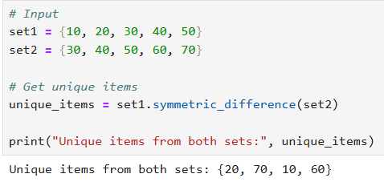

**2. Write a Python program to Return a set of elements present in Set A or B, but not both.**

**Input: set1 = {10, 20, 30, 40, 50}**

**set2 = {30, 40, 50, 60, 70}**

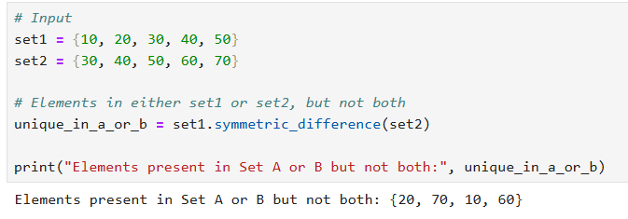

**3. Write a Python program to Check if two sets have any elements in common. If yes, display the common elements.**

**Input: set1 = {10, 20, 30, 40, 50}**

**set2 = {60, 70, 80, 90, 10}**

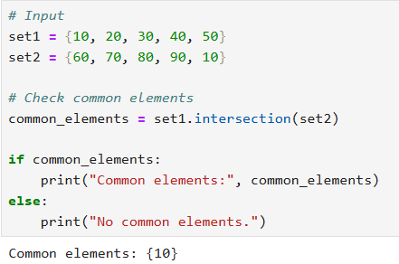

**4. Write a Python program to Remove items from set1 that are not common to both set1 and set2.**

**Input: set1 = {10, 20, 30, 40, 50}**

**set2 = {30, 40, 50, 60, 70}**

